**AIM:TO CALCULATE ELECTRICITY BILL USING CURSORS**

CREATE TABLE EBILL(EBNO NUMBER(5),NAME VARCHAR(15),UNITS NUMBER(4),CHARGES NUMBER(3));

INSERT INTO EBILL(EBNO,NAME,UNITS)VALUES(:EBNO,:NAME,:UNITS);

SELECT * FROM EBILL;

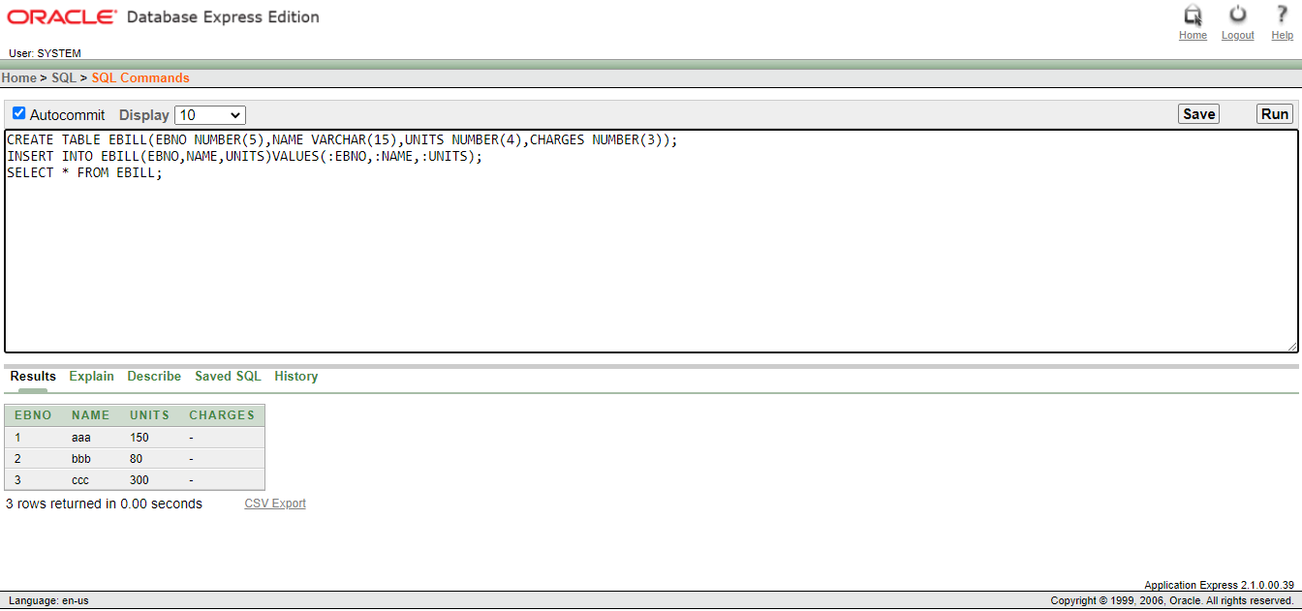

DECLARE

CURSOR CUR IS SELECT * FROM EBILL;

BEGIN

FOR I IN CUR

LOOP

IF I.UNITS<=100 THEN

UPDATE EBILL SET CHARGES=I.UNITS*1 WHERE EBNO=I.EBNO;

ELSIF I.UNITS>100 AND I.UNITS<=200 THEN

UPDATE EBILL SET CHARGES=I.UNITS*2 WHERE EBNO=I.EBNO;

ELSE

UPDATE EBILL SET CHARGES=I.UNITS*3 WHERE EBNO=I.EBNO;

END IF;

END LOOP;

END;

SELECT * FROM EBILL;

